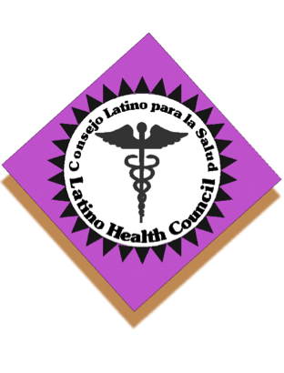
Latino Health Council

GHC Capitol clinic

675 W. Washington Ave. Madison

August 25, 2016
9:30-11:30

0. Continental breakfast

1. Introductions

2. Minutes (approval/corrections)

3. Announcements/check-in

4. Old business:

- Health fair planning

- Subcommittees’ meetings/updates:
  - Finances
  - Membership
- Website

5. New business:

- GHC (Presentation)

Meeting adjourned

Next meeting: September 22, 2016

Meeting place: UW Health

Minutes: Kristy Jones

